IDEAS2ACTION THIRD RECYCLING AWARDS 2018
Friday 28 September 7pm
Cattistock Room, Poole Civic Centre

AWARDS NOMINATION FORM 2018

Charity No1170422
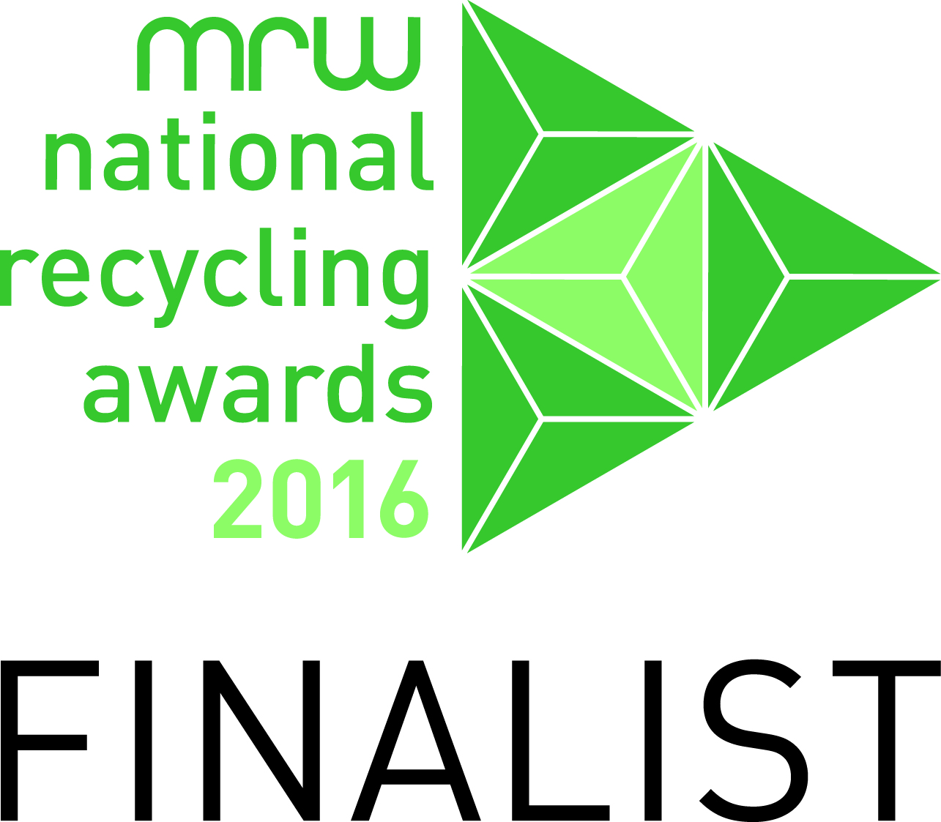

Following on from the success of our first two Recycling Awards events, we are once again looking for nominations. We meet and hear of so many individuals, companies, schools and other organisations who go that extra mile when it comes to recycling. So if you know anyone and would like to nominate them (please get their agreement that they are happy to be nominated, we don’t want to choose a winner and find they are unhappy about it!), these are the categories:

  - Adult recycler (over 18)
  - A team of recyclers from a private/statutory/voluntary organisation
  - A team of recycling volunteers (a group of individuals who come together to recycle)
  - The No 1 recycler (someone who has really gone the extra mile)
  - Young recycler (under 18)
  - A private/statutory/voluntary organisation whose employees recycle (but not where its main business is recycling)
  - School or college
  - Win on Waste on Wheels (recognising an older housebound person who has enthusiastically got involved in this new pilot project)

About the person/company/team you want to nominate
Category number
Name (for categories 1,4,5,8)
Company, school, or team name (for categories 2, 3,6,7)
Their contact email or if they don’t have an email address please add their postal address
Phone number

Say why they deserve this nomination (please continue on another sheet if necessary)
About you:
Name
Contact email or postal address
Phone
Please complete and return by email: contact@ideas2action.org.uk or by post to: ‘Nominations’, Ideas2Action c/o Poole CVS, Floor 3, Beech House, 28-30 Wimborne Road, Poole BH15 2BU as soon as possible or the latest by 18th August.

