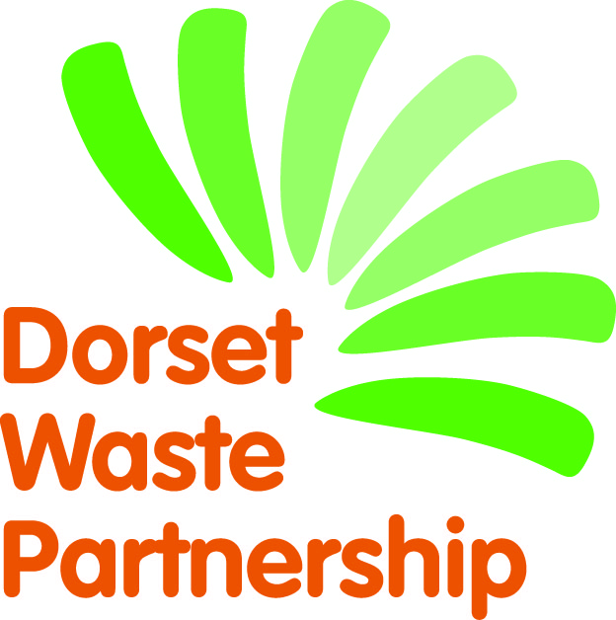
Produced by Ideas2Action on behalf of Dorset Waste Partnership
‘We Need That – Dorset’
NEEDS CONTACT FORM

The following details will appear in the booklet.
[please type or print]
Organisation name
Name of contact
Address
Email
Phone No
If your main contact details are different to the above (these won’t be used in the booklet) then please add them below:
Name of contact
Address
Email
Phone No
Important
To help us with our monitoring and evaluation of the project, please keep a note of any items you receive as a direct response from appearing in the We Need That! directory and ask how the donor first heard about it. Thank you.
By completing this form and appearing in the booklet we agree that:
- You will keep our details for the sole purpose of our entry(s) in the We Need That – Dorset recycling directory and that our details will only be used for the purpose of appearing in the directory. We also understand that we can ask you to unsubscribe us at any time and you will permanently delete our details. However, we appreciate that there will have been paper copies made which will include our details.
- The items we request will be used by us within our organisation, or to help us with our fundraising.
- We will be responsible for the delivery and/or collection of items from donors.
- Dorset Waste Partnership accepts no liability or responsibility in relation to the delivery and/or collection of items. Dorset Waste Partnership is only facilitating in the brokerage of reusable items.
PLEASE COMPLETE AND RETURN BY Friday 3 August 2018 by email: contact@ideas2action.org.uk or If returning forms by post please send to Monique Munroe, Ideas2Action c/o Poole CVS, Floor 3, Beech House, 28-30 Wimborne Road, Poole BH15 2BU.

Signed:
(if you don’t have an electronic signature please just type your name)
Job title:
Date:

