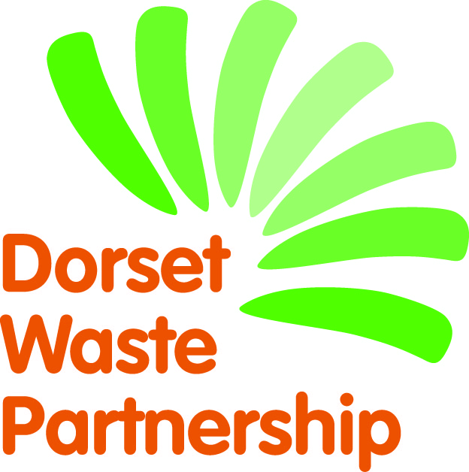
Produced by Ideas2Action on behalf of Dorset Waste Partnership
‘We Need That – Dorset’
NEEDS CONTACT FORM

The following details will appear in the booklet.
[please type or print]
Name
Area of Dorset you live in
Email
Phone No
If your main contact details are different to the above (these won’t be used in the booklet) then please add them below:
Name of contact
Address
Email
Phone No
Important
To help us with our monitoring and evaluation of the project, please keep a note of any items you receive as a direct response from appearing in the We Need That! directory and ask how the donor first heard about it. Thank you.

By completing this form and appearing in the booklet I agree that:
- You will keep my details for the sole purpose of my entry(s) in the We Need That – Dorset recycling directory and that my details will only be used for the purpose of appearing in the directory. I also understand that I can ask you to unsubscribe me at any time and you will permanently delete my details. However, I appreciate that there will have been paper copies made which will include my details.
- The item(s) I have requested will be only be used by me for my personal use (or on behalf of a not-for-profit group). The item(s) will not be used as a profit-making venture, unless the profits are donated to charities or other not-for-profit organisations.
- I will be responsible for the delivery and/or collection of items.
- Dorset Waste Partnership accepts no liability or responsibility in relation to the delivery and/or collection of items. Dorset Waste Partnership is only facilitating in the brokerage of reusable items.
Signed:
PLEASE COMPLETE AND RETURN BY Friday 3 August 2018
If returning forms by post please send to Monique Munroe, Ideas2Action c/o Poole CVS, Floor 3, Beech House, 28-30 Wimborne Road, Poole BH15 2BU.

(if you don’t have an electronic signature please just type your name)
Date:

