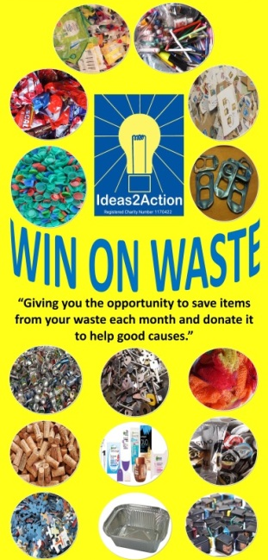

December Win on Waste® dates:
1 Broadstone (Broadstone Library 10-11am)
1 Wimborne (Wimborne Library 10.30am-12noon)
1 Hamworthy (Hamworthy Library 11-12)
5 Barnabas (Church of the Good Shepherd, Herbert Avenue, Poole 11.30-2pm)
8 Ashley Road, Parkstone (Co-op supermarket 10.30am -12noon)
8 Creekmoor (Creekmoor Library 11.30am-12.30pm)
8 Corfe Mullen 10.30-12 (Corfe Mullen Library)
8 Canford Heath (Coffee House Cafe 10-11am)
15 Oakdale (Oakdale Library 10.30am-12noon)
15 Merley (The Lantern Church 10.30-11.30am)
15 Southbourne (Southbourne Library 10.30am to 12 noon)

There will be no sessions in Ashley Cross, Kinson, Turlin Moor or Westbourne in December.

- Livability Holton Lee no longer run monthly Saturday sessions. If you have anything to donate please drop off items during the week at the Coffee Shack, Holton Lee, Holton Heath.

