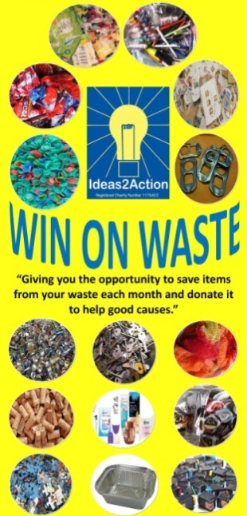
April 2019 Win on Waste® dates:

Easter changes: there will be no Oakdale session on the 20th and
Southbourne will move to the 27th.

NEW SESSION STARTING ON SATURDAY 4TH MAY: Christchurch Win on Waste 10am-12noon at Christchurch Library.

3 Barnabas Win on Waste, Church of the Good Shepherd, Herbert Avenue 11.30-2)
6 Broadstone (Broadstone Library 10-11am)
6 Hamworthy (Hamworthy Library 11-12)
6 Wimborne (Wimborne Library 10.30am-12noon)
13 Ashley Road, Parkstone (Co-op supermarket 10.30am—12noon)
13 Creekmoor (Creekmoor Library 11.30am-12.30pm)
13 Corfe Mullen 10.30-12 (Corfe Mullen Library)
13 Canford Heath (Coffee House Cafe 10-11am)
20 Merley (The Lantern Church 10.30-11.30am)
25 Turlin Moor (St Gabriel’s Church 9am-12noon)
27 Ashley Cross (Parkstone Library 10.30-12)
27 Kinson (Kinson Library 10.30-11.30)
27 Southbourne (Southbourne Library 10.30am to 12 noon)
27 Westbourne (Westbourne Library 10-11)

· Livability Holton Lee no longer run monthly Saturday sessions. If you have anything to donate please drop off items during the week at the Coffee Shack, Holton Lee, Holton Heath.

