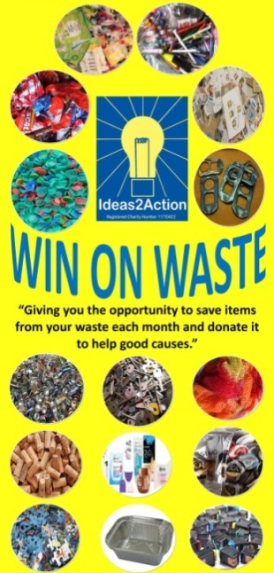

May 2019 Win on Waste® dates:

1 Barnabas Win on Waste, Church of the Good Shepherd, Herbert Avenue 11.30-2)
4 Broadstone (Broadstone Library 10-11am)
4 Christchurch launches (Christchurch Library 10-12)
4 Hamworthy (Hamworthy Library 11-12)
4 Wimborne (Wimborne Library 10.30am-12noon)
11 Ashley Road, Parkstone (Co-op supermarket 10.30am—12noon)
11 Creekmoor (Creekmoor Library 11.30am-12.30pm)
11 Corfe Mullen 10.30-12 (Corfe Mullen Library)
11 Canford Heath (Coffee House Cafe 10-11am)
18 Oakdale (Oakdale Library 10.30am-12noon)
18 Merley (The Lantern Church 10.30-11.30am)
18 Southbourne (Southbourne Library 10.30am to 12 noon)
25 Ashley Cross (Parkstone Library 10.30-12)
25 Kinson (Kinson Library 10.30-11.30)
25 Westbourne (Westbourne Library 10-11)
30 Turlin Moor (St Gabriel’s Church 9am-12noon)

· Livability Holton Lee no longer run monthly Saturday sessions. If you have anything to donate please drop off items during the week at the Coffee Shack, Holton Lee, Holton Heath.

