IDEAS2ACTION FOURTH RECYCLING AWARDS 2019
Friday 27 September 7pm
Cattistock Room, Poole Civic Centre

AWARDS NOMINATION FORM 2019

Charity No1170422
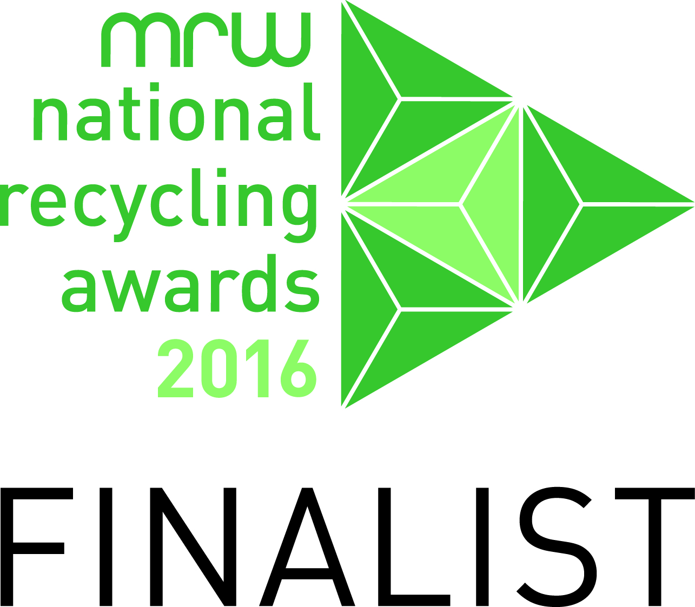

Now in its fourth year, we are proud to once again run our Recycling Awards event with the aim of recognising all the wonderful individuals, schools, private, statutory and voluntary organisations who go the extra mile when it comes to recycling. If you would like to nominate anyone (please get their permission as we don’t want to choose a winner and find they are unhappy about it!), these are the categories:

  - Adult recycler (over 18)
  - A team of recyclers from a private/statutory/voluntary organisation
  - A team of recycling volunteers (a group of individuals who come together to recycle)
  - The No 1 recycler (someone who has really gone the extra mile)
  - Young recycler (under 18)
  - A private/statutory/voluntary organisation whose employees recycle (but not where its main business is recycling)
  - School or college
  - Win on Waste on Wheels (recognising an older housebound person who has enthusiastically got involved in this pilot project)

About the person/school/organisation/team you want to nominate
Category number
Name (for categories 1,4,5,8)
Company, school, or team name (for categories 2, 3,6,7)
Their contact email or if they don’t have an email address please add their postal address
Phone number

Say why they deserve this nomination, give as much information as you can about them and their recycling. (please continue on another sheet if necessary)
About you:
Name
Contact email or postal address
Phone
Please complete and return by email: contact@ideas2action.org.uk or by post to: ‘Nominations’, Ideas2Action c/o Bournemouth & Poole CVS, Floor 3, Beech House, 28-30 Wimborne Road, Poole BH15 2BU as soon as possible or the latest by Monday 12th August.

