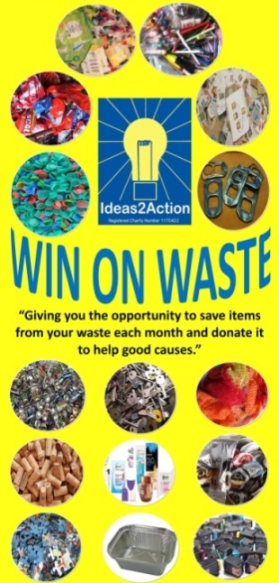
July 2019 Win on Waste® dates

6 Broadstone (Broadstone Library 10-11am)
6 Christchurch (Christchurch Library 10-12noon)
6 Hamworthy (Hamworthy Library 11-12noon)
6 Wimborne (Wimborne Library 10.30-12noon)
13 Ashley Road, Parkstone (Co-op supermarket 10.30-12noon)
13 Creekmoor (Creekmoor Library 11.30-12.30pm)
13 Corfe Mullen (Corfe Mullen Library 10.30-12noon)
13 Canford Heath (Coffee House Cafe 10-11am)
13 Poole Town (The Spire, Poole High Street 10.30-12noon)
20 Oakdale (Oakdale Library 10.30-12noon)
20 Merley (The Lantern Church 10.30-11.30am)
20 Southbourne (Southbourne Library 10.30-12noon)
27 Ashley Cross (Parkstone Library 10.30-12noon)
27 Kinson (Kinson Library 10.30-11.30am)
27 Westbourne (Westbourne Library 10-11am)

· Livability Holton Lee no longer run monthly Saturday sessions. If you have anything to donate please drop off items during the week at the Coffee Shack, Holton Lee, Holton Heath.
· Beehive (Formerly Barnabas) Win on Waste will be restarting soon.

