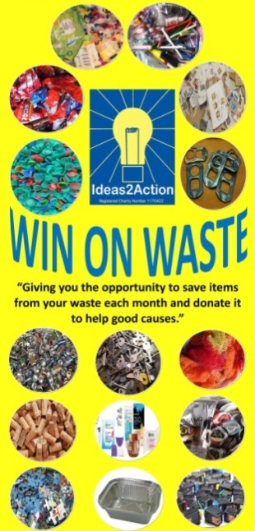

June 2019 Win on Waste® dates:

1 Broadstone (Broadstone Library 10-11am)
1 Christchurch (Christchurch Library 10-12)
1 Hamworthy (Hamworthy Library 11-12)
1 Wimborne (Wimborne Library 10.30am-12noon)
5 Barnabas Win on Waste, Church of the Good Shepherd, Herbert Avenue 11.30-2)
8 Ashley Road, Parkstone (Co-op supermarket 10.30am—12noon)
8 Creekmoor (Creekmoor Library 11.30am-12.30pm)
8 Corfe Mullen 10.30-12 (Corfe Mullen Library)
8 Canford Heath (Coffee House Cafe 10-11am)
15 Oakdale (Oakdale Library 10.30am-12noon)
15 Merley (The Lantern Church 10.30-11.30am)
15 Poole Town (The Spire, Poole High Street 10-12)
15 Southbourne (Southbourne Library 10.30am to 12 noon)
27 Turlin Moor (St Gabriel’s Church 9am-12noon)
29 Ashley Cross (Parkstone Library 10.30-12)
29 Kinson (Kinson Library 10.30-11.30)
29 Westbourne (Westbourne Library 10-11)

· Livability Holton Lee no longer run monthly Saturday sessions. If you have anything to donate please drop off items during the week at the Coffee Shack, Holton Lee, Holton Heath.

